Brake Test On DC Shunt Motor
In this article we are going to discuss about brake test on d.c. motor.Brake test is also a method of finding efficiency of dc motors.We took dc shunt motor as running machine.Brake test also called as direct loading test of testing the motor. Because loading will be applied directly on shaft of the motor by means of a belt and pulley arrangement.

Procedure of Brake Test On DC Shunt Motor
1. By adjusting the handle of the pulley take different readings of the spring balance.
2. The tension in the belt can be adjusted using the handle. The tension in kg can be obtained from the spring balance readings.
3. Adjusting the load step by step till full load, number of readings can be obtained.By increasing the load is slowly, adjust to get rated load current.
4. The power developed gets wasted against the friction between belt and shaft. Due to the braking action of belt the test is called brake test.
5. The speed can be measured by tachometer. Thus all the motor characteristics can be plotted.
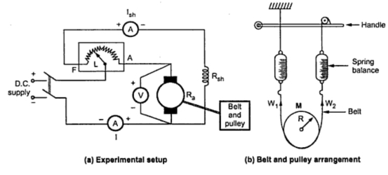
You can refer figure for the experimental setup for performing brake test on a d.c. shunt motor,belt & pulley arrangement mounted on the shaft of the motor.

Calculation Of Brake Test On DC Shunt Motor
Let R (or) r= Radius of pulley in meters
N = Speed in r.p.m.
W1 = Spring balance reading on tight side in kg
W2 = Spring balance reading on slack side in kg
So net pull on the belt due to friction at the pulley is the difference between the two spring balance readings.

Net pull on the rope = (W - S) kg = (W - S) X 9.81 newtons......(1)

As radius R and speed N are known, the shaft torque developed can be obtained as,
Tsh = Net pull X R=(W - S) X 9.81 X R .....(2)
Hence the output power can be obtained as,Say speed of the pulley is N r.p.m., then,The above equation shows the output power of dc shunt motor in brake test.
Now let, V = Voltage applied in volts
I = Total line current drawn in amps.
As we know V,I are input parameters of dc motors in brake test.then,
Pin=V.I Watts .....(3)
We have output and input.Then why late go and find the efficiency of dc shunt motor.

Efficiency (η)=Output/Input [No units]
From equation (2) & (3)
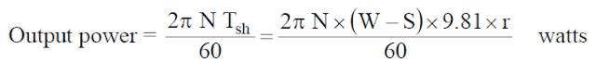

Advantages Of Brake Test On DC Shunt Motor
1. Actual efficiency of the motor under working conditions can be found out.
2. Brake test is simple and easy to perform.
3. It is not only for dc shunt motor, also can be performed on any type of d.c. motor.

Disadvantages Of Brake Test On DC Shunt Motor
1. In brake test due the belt friction lot of heat will be generated and hence there is large dissipation of energy.
2. Cooling arrangement is necessary to minimize the heat. Mostly in our laboratories we use water as cooling liquid.
3. Convenient only for small rated machines due to limitations regarding heat dissipation arrangements.
4.Power developed gets wasted hence brake test method is little expensive.
5. The efficiency observed is on lower side.

Swinburne’s Test of DC Machine
Calculation of Efficiency
Calculation of Efficiency When the Machine is Motoring on Load
Calculation of Efficiency When the Machine is Generating on Load
Advantages of Swinburne's Test
• Disadvantages
This method is an indirect method of testing a dc machine. It is named after Sir James Swinburne. Swinburne's test is the most commonly used and simplest method of testing of shunt and compound wound dc machines which have constant flux. In this test the efficiency of the machine at any load is pre-determined. We can run the machine as a motor or as a generator. In this method of testing no load losses are measured separately and eventually we can determine the efficiency.
The circuit connection for Swinburne's test is shown in figure below. The speed of the machine is adjusted to the rated speed with the help of the shunt regulator R as shown in figure.
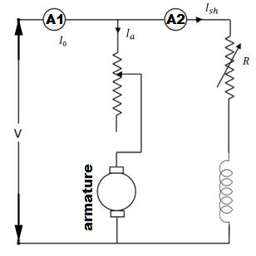
Connection Diagram of Swinburne's Test

Calculation of Efficiency
Let, I₀ is the no load current ( it can be measured by ammeter A₁ )
I_{sh} is the shunt field electric current ( it can be measured by ammeter A₂ )
Then, no load armature electric current = (I₀ - I_{sh})
Also let, V is the supply voltage. Therefore, No load power input = VI₀ watts.
In Swinburne's test no load power input is only required to supply the losses. The losses occur in the machine mainly are:
Iron losses in the core
Friction and windings losses
Armature copper loss.
Since the no load mechanical output of the machine is zero in Swinburne's test, the no load input power is only used to supply the losses.
The value of armature copper loss = (I₀ - I_{sh})² R_{a}
Here, R_{a} is the armature resistance.
Now, no to get the constant losses we have to subtract the armature copper loss from the no load power input.
Then, Constant losses W_{C} = VI₀ -(I₀ - I_{sh})² R_{a}
After calculating the no load constant losses now we can determine the efficiency at any load.
Let, I is the load current at which we have to calculate the efficiency of the machine.
Then, armature electric current (I_{a}) will be (I - I_{sh}), when the machine is motoring.
And I_{a} = (I + I_{sh}), when the machine is generating.

Calculation of Efficiency When the Machine is Motoring on Load
Power input = VI
Armature copper loss, P_{CU} = I² R_{a} = (I - I_{sh})²R_{a}
Constant losses, W_{C} = VI₀ -(I₀ - I_{sh})² R_{a}
Total losses = P_{CU} + W_{C}
∴ Efficiency of the motor:

Calculation of Efficiency When the Machine is Generating on Load
Power input = VI
Armature copper loss, P_{CU} = I² R_{a} = (I + I_{sh})² R_{a}
Constant losses, W_{C} = VI₀ - (I₀ - I_{sh})² R_{a}
Total losses = P_{CU} + W_{C}
∴ Efficiency of the generator:

Advantages of Swinburne's Test
The main advantages of this test are :
- This test is very convenient and economical as it is required very less power from supply to perform the test.
- Since constant losses are known, efficiency of Swinburne's test can be pre-determined at any load.

Disadvantages of Swinburne's Test
The main disadvantages of this test are :
1. Iron loss is neglected though there is change in iron loss from no load to full load due to armature reaction.
2. We cannot be sure about the satisfactory commutation on loaded condition because the test is done on no-load.
3. We can’t measure the temperature rise when the machine is loaded. Power losses can vary with the temperature.
4. In dc series motors, the Swinburne’s test cannot be done to find its efficiency as it is a no load test.

Hopkinson's Test or Regenerative Test On DC Motor
In the previous post we have seen how to determine the efficiency of DC machines using brake test. Hopkinson's test is also a test of finding the efficiency of a dc motor. Hopkinson's test or regenerative test is a full load test and it requires two identical machines which are coupled to each other.In this test two identical d.c. machines mechanically coupled to each other and simultaneously tested.One is operated as generator another one as motor,hence we can find efficiency of two dc machines simultaneously.So output power of dc machines are going to be wasted.The mechanical output of motor given to generator through shaft to shaft mechanical coupling.And generator's electrical power supplied to run the motor,where losses will be supplied by external power source.

If there are no losses in the motor-generator set,the electrical power from the generator and mechanical output from motor are enough to run motor,generator respectively.So no need of any external power supply to the motor.But due to losses, the generator output is not sufficient to drive the motor. Thus motor takes current from the supply to account for losses.

Observe circuit diagram of Hopikinson's test. The two shunt dc machines are connected in parallel. In that two machines,one is started as a motor another one operated as generator.Here the only rotor connections are mentioned,stator connections are not shown for simplicity.

Connection Diagram of Hopkinson's Test
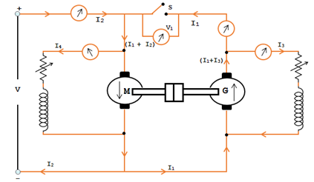
First switch S is kept open. The other machine which is coupled to first will act as load on first which is acting as motor. Thus second machine will act as a generator.With the help of field rheostat speed of the motor is adjusted to normal value.Note down the observed voltmeter readings.With the help of generator field rheostat voltage of the generator is adjusted up to voltmeter reading is zero.This is to make sure generator voltage is having same magnitude and polarity of that of supply voltage.By making this we can prevent heavy circulating current flowing in the local loop of armatures on closing the switch.

Now close the switch S. The two machines can be put into any load by adjusting their field rheostats. The generator current I2 can be adjusted to any value by increasing the excitation of generator or by reducing the excitation of motor. The various reading shown by different ammeters are noted for further calculations.

The input to the motor is nothing but the output of the generator and small power taken from supply. The mechanical output given by motor after supplying losses will in turn drive the generator.

Calculation of Efficiency by Hopkinson's Test
Let V = Supply voltage
Motor power Input = V(I1 + I2)
Generator power Input = VI1
We can determine the efficiency of DC machines in two cases.
Case 1: Assuming that the efficiency of both the machines are same.
Case 2: Assuming both the machines has same iron loss, friction loss and windage loss.

Case 1:
Assuming that the efficiency of both the machines are same.

Motor output power = η x Motor Input power

= η V(I1+I2)

i.e., Motor Input power = Generator Input

Now the Generator output = η x generator Input

= η x ηV(I1 +I2)

= η2 V(I1+I2)

VI1 = η2V(I1+I2)

∵ Generator output η = √ {I1 / (I1+I2)}

Note: The above expression is used to determine the efficiency satisfactorily perfect for a rough test. If case need to find more accuracy then the efficiency of the two machines can be determined separately using the below expressions.
Case 2:
Assuming both the machines has same iron loss, friction loss and windage loss.

However the iron loss, friction loss and windage loss of both the machines will be same due to both the machines are identical. On this notion we can find the efficiency of each machine.
It is not necessary to assume that the efficiency of both the machines are same. It is due to that both the DC machines don’t have the same armature winding and the field winding.
Let,
Ra = Armature winding resistance of individual machines.
I3 = Shunt field current Generator G
I4 = Shunt fief current of Motor M

Generator armature copper loss = (I1+I32) Ra

Motor armature copper loss = (I1 + I2 – I42) Ra

Shunt field copper loss in G = VI3

Shunt field copper loss in M = VI4

Power drawn from the DC source is VI2 and is equal to the total losses of motor and generator.
VI2 = Motor and Generator total losses

To get the iron loss, friction and windage loss subtract the armature copper loss and shunt copper loss of both the machine from VI2.

Total losses of 2 machines (M & G)

= VI2 – [(I1+I3)2Ra + (I1+I2-I42Ra+VI3+VI4)] = W

To find the individual machine losses divide by 2
i.e. Total losses of each machine = W/2

To find the efficiency of Motor in hopkinson's test
Input motor power = V(I1 + I2)

Total Losses = (I1+I2-I42)Ra + VI4 + (W/2)

= Wm

Efficiency of Motor ηm = (Input – Losses) / Input

= [V(I1+I2) – Wm] / [V(I1+I2)]

To find the efficiency of Generator in hopkinson's test
Generator output power = VI1

Total Losses = (W/2) + (I1+I32)Ra + VI3

= Wg

Efficiency of Generator ηg = VI1 / (VI1+Wg)

Advantages of Hopkinson's Test or Regenerative Test On DC Motor

The various merits of Hopkinson's test are,
1. This test is very economical because it requires only very small power just to compensate the losses which is very small value when compared to full-load power of the motor-generator coupled system.
2. This is performed at full load condition so we can take flux distortion into account.
3. There is no need for arranging any actual load. Similarly by changing the field currents of two machines, the load can be easily changed and a load test over complete range of load can be taken.
4. This test is better suited in case of large machines.

Disadvantages of Hopkinson's Test or Regenerative Test On DC Motor
The various demerits of Hopkinson's test are,
- It is a big task to check for two identical machines needed for Hopkinson's test.
2. We can not load two machines equally all the time.
3. It is not possible to get separate iron losses for the two machines though they are different because of their excitation.
4. It is difficult to operate the machines at rated speed because field currents vary widely.
5.The machines are not loaded equally in case of small machines which may lead to difficulty in analysis.

Retardation Test or Running Down on D.C Machines
In the previous articles we have seen brake test,hopkinson's-test which are essential to find out dc machine efficiency.Now in this article we are going to discuss about retardation test on dc machines.Retardation test is also called as running down test.This is very efficient way to find out stray losses in dc shunt motors.In this test we get total stray losses nothing but combination of mechanical (friction & windage) and iron losses of the machine.
The circuit diagram of retardation test on dc machines shown below.A1,A2 are armature terminals.

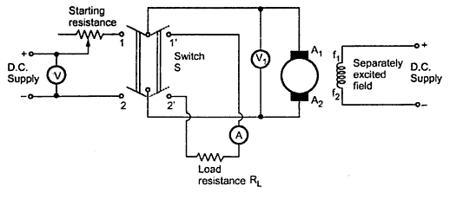

Procedure of Retardation Test on D.C Machines
The main points in the retardation or running down test are discussed below,
1. Now start the dc machine normally,run the machine slightly above the rated speed by adjusting resistance.
2. After achieving above the rated speed just cutoff the power supply to the armature,but keeping field normally excited.
3. Now wait for some time to fall down of speed below rated,then using the tachometer note down the values of speed (in rpm) and time (in sec).
4. The armature consequently slows down and the amount of kinetic energy present in the armature is used to supply the rotational or stray losses which includes iron, friction and winding loss.

If I is the amount of inertia of the armature ans is the angular velocity.
Kinetic energy of armature = 0.5 Iω².
Rotational losses, W = Rate of change of kinetic energy.
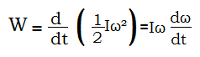
I=Moment of inertia of the armature.

In retardation test of dc machines, the rotational losses are given by

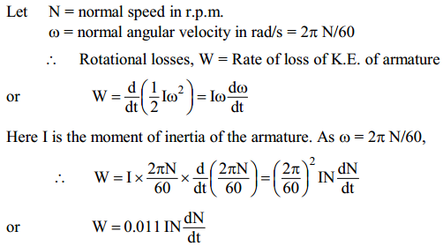

We have the formula of stray losses in retardation test of machines,but here moment of inertia (I) of the armature is unknown.To find out I we have two different methods.We need to find dN/dt too.

Determination of dN/dt in retardation test of dc machines

The voltmeter (V1) across the armature will give the value of back e.m.f. of the motor. We know that back e.m.f. is proportional to speed so that we calibrate the voltmeter to show the speed reading directly.
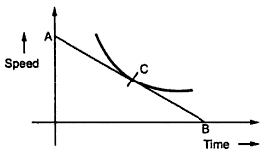
When motor is cut off from the supply, the speed decrease in speed is noted with the help of stop watch.You can observe curve drawn between calibrated values of time and speed.

At any point C corresponding to normal speed, a tangent AB is drawn. Then the value obtained from below can be substituted in the expression for W which can give the rotational looses.

dN/dt=OA(in rpm)/OB(in seconds)

Methods of finding moment of inertia (I) in retardation test
(a) Using Flywheel
(b) Without using Flywheel

(a) Using Flywheel in retardation test
In this method we use the fly wheel whose moment of inertia is I1 to find the I value. In first case retardation test is performed with armature alone and dN/dt1 is determined. In next case,flywheel is employed on the shaft,change in speed, dN/dt2 is noted.Addition of fly-wheel will not materially affect the rotational losses.
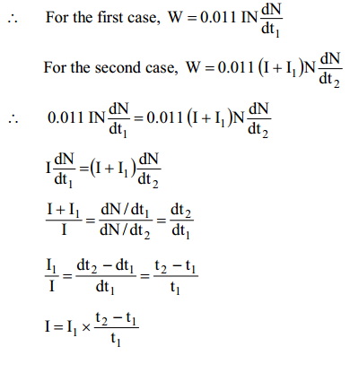
Since the values of I1, t1 and t2 are known, the moment of inertia I of the
armature can be determined.

(b) Without using Flywheel in retardation test
Without using flywheel, I is eliminated from the expression by an experiment. First, retardation test is performed with armature alone. The rotational losses are given by;
W = 0.011 IN dN/dt1

Next the motor is loaded with a known amount of power W' with a brake. For
the same change in speed, dN/dt2 is noted. Then,
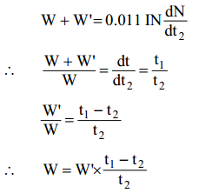
Since the values of W', t1 and t2 are known, the value of W can be determined.

The electric loading in retardation test W' (or extra power loss) is given by;
W' = average voltage x average current = V' I'a.
This is the simple article on retardation test on dc machines.In the nest post we try to share a pdf on retardation test lab manual.

